Infrastructure as a Service (IaaS)
# Source: AI Source: Provided by: [Data Path: Persons Table -> ID Column: 1, Name_En Column: Motasem Essam] -> From: [ChatGPT] on [1/16/2026]
IaaS is a cloud computing service model that provides virtualized computing resources over the Internet.
It allows users to rent IT infrastructure—such as servers, storage, networking, and operating systems—on-demand, without owning physical hardware.

Definition
# Source: AI Source: Provided by: [Data Path: Persons Table -> ID Column: 1, Name_En Column: Motasem Essam] -> From: [ChatGPT] on [1/16/2026]
IaaS:
- Provides virtualized hardware resources as a service
- Users manage operating systems, applications, and data
- The cloud provider manages physical servers, storage, and networking

Architecture Diagram
# Source: AI Source: Provided by: [Data Path: Persons Table -> ID Column: 1, Name_En Column: Motasem Essam] -> From: [ChatGPT] on [1/16/2026]
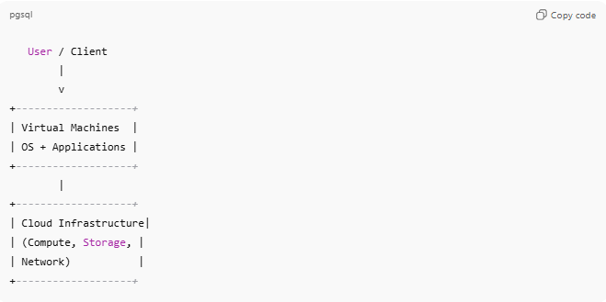
User / Client
|
v
+-------------------+
| Virtual Machines |
| OS + Applications |
+-------------------+
|
+-------------------+
| Cloud Infrastructure|
| (Compute, Storage, |
| Network) |
+-------------------+
- User responsibility: OS, middleware, apps, and data
- Provider responsibility: Physical servers, storage, networking, virtualization

Key Features
# Source: AI Source: Provided by: [Data Path: Persons Table -> ID Column: 1, Name_En Column: Motasem Essam] -> From: [ChatGPT] on [1/16/2026]
- On-demand provisioning of resources
- Scalable: easily add or remove compute/storage
- Pay-as-you-go pricing
- Virtualization of servers and storage
- Full control over the OS and applications

Examples
# Source: AI Source: Provided by: [Data Path: Persons Table -> ID Column: 1, Name_En Column: Motasem Essam] -> From: [ChatGPT] on [1/16/2026]
- Amazon Web Services (AWS EC2) – Virtual servers
- Microsoft Azure – Virtual machines and storage
- Google Compute Engine (GCE) – On-demand compute resources
- DigitalOcean Droplets – Simple cloud VMs

Advantages
# Source: AI Source: Provided by: [Data Path: Persons Table -> ID Column: 1, Name_En Column: Motasem Essam] -> From: [ChatGPT] on [1/16/2026]
- Reduces cost of buying hardware
- Highly scalable and flexible
- Quick deployment of virtual servers
- Full control over software stack

Disadvantages
# Source: AI Source: Provided by: [Data Path: Persons Table -> ID Column: 1, Name_En Column: Motasem Essam] -> From: [ChatGPT] on [1/16/2026]
- Users are responsible for OS and application maintenance
- Security and patch management are user responsibilities
- Can become expensive for large-scale usage

Simple Analogy
# Source: AI Source: Provided by: [Data Path: Persons Table -> ID Column: 1, Name_En Column: Motasem Essam] -> From: [ChatGPT] on [1/16/2026]
- IaaS: Renting a furnished apartment without utilities
  - You provide the furniture and appliances (OS, apps)
  - Landlord provides the building, plumbing, electricity (hardware, networking, storage)

